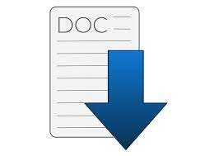

**Author Team 4 :**

Abdelrahman Mohamed Gomaa

Abdelrahman Mohamed Ahmed

Islam Abu elsoud

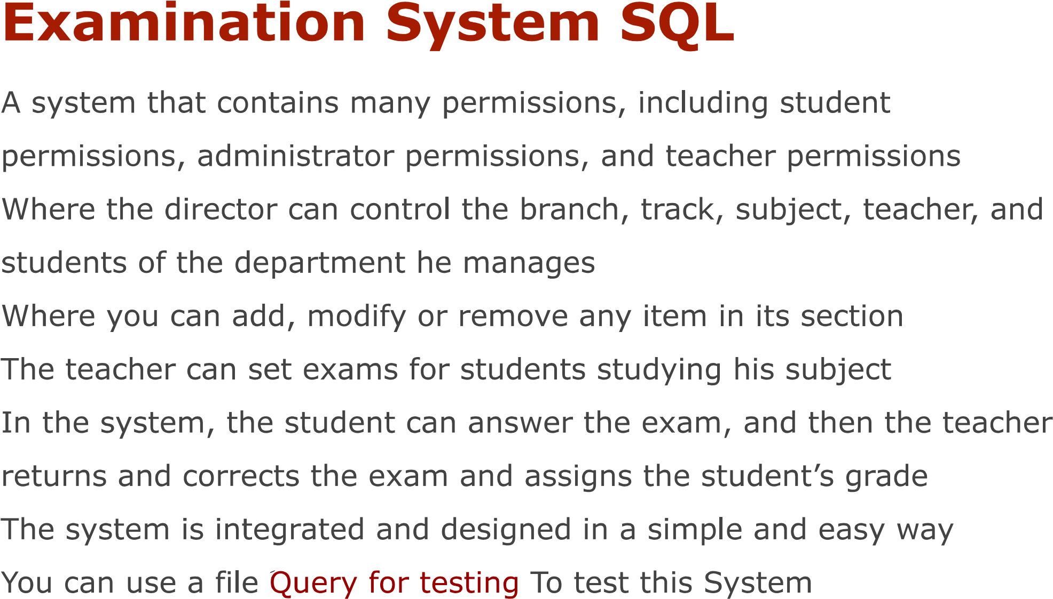

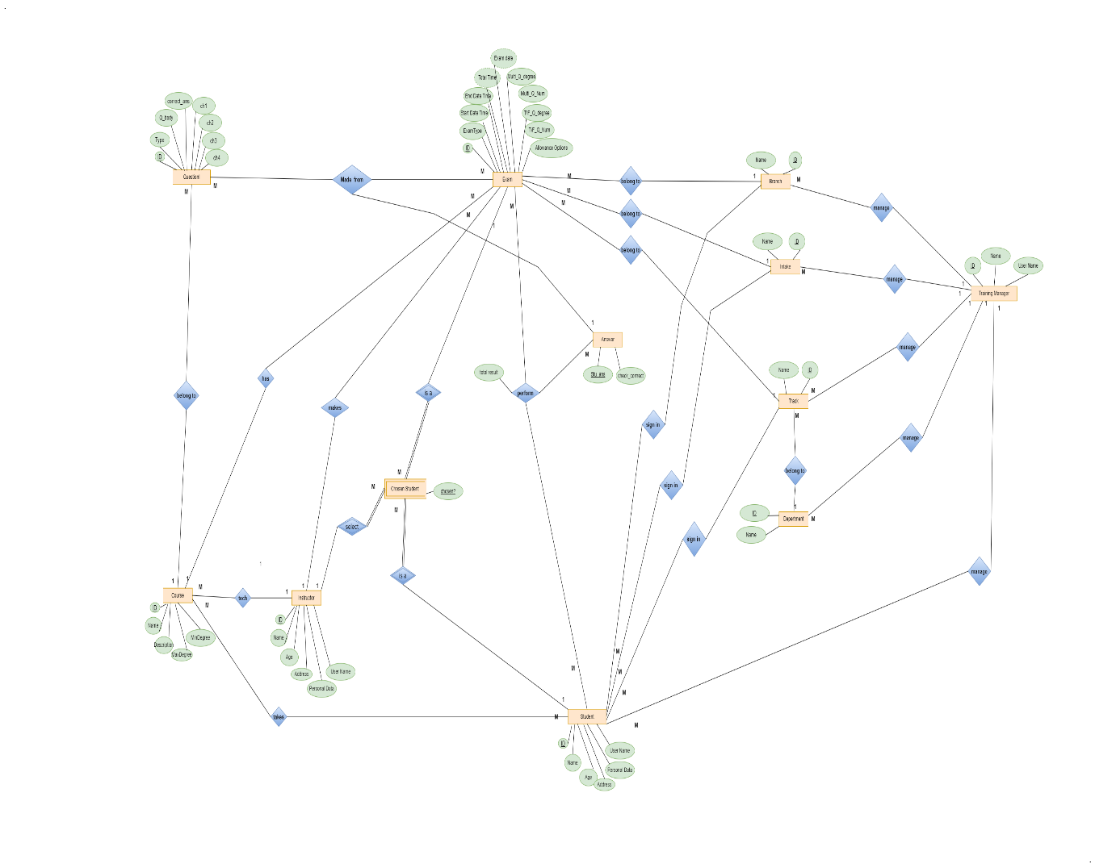

**Mapping**

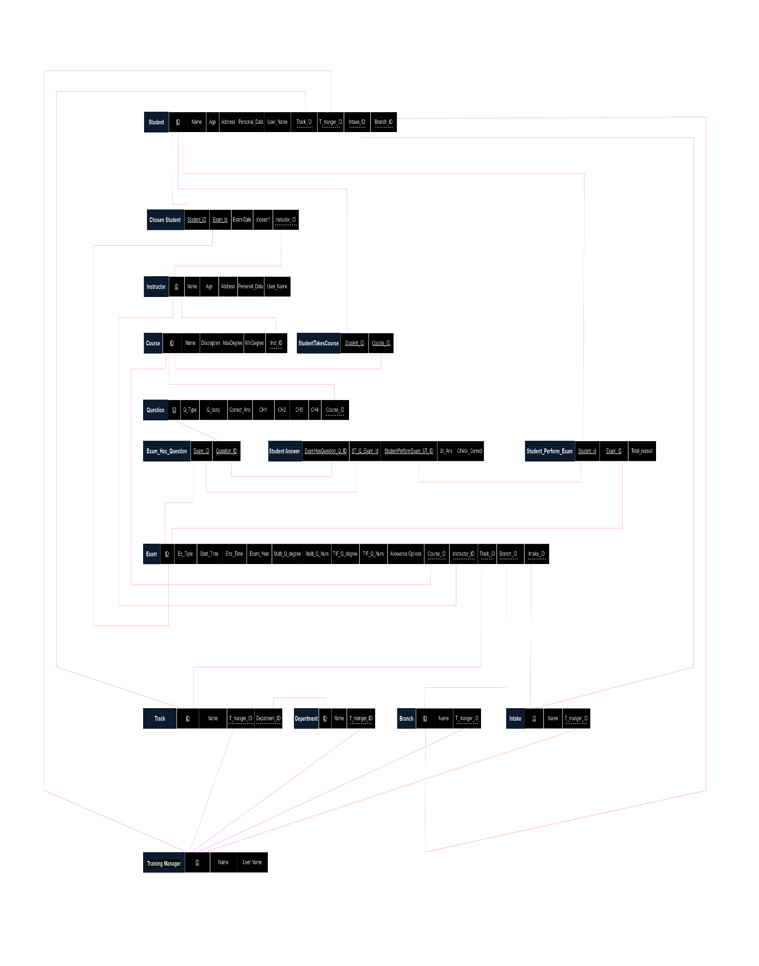

**Diagram**

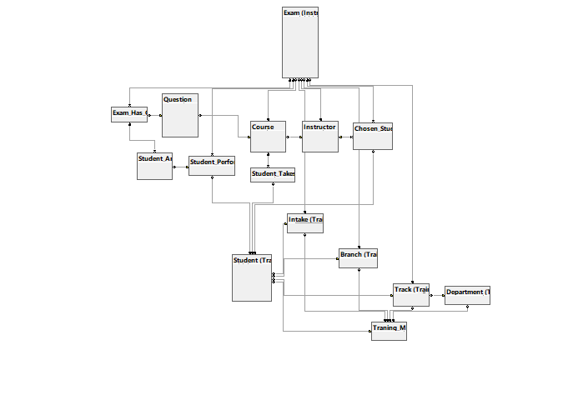

Table Of Contains

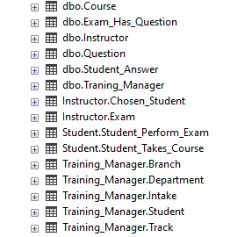

**Stored Procedures**

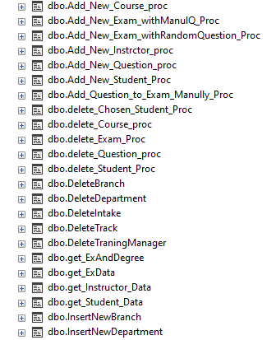

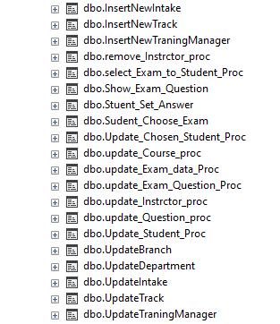

**Views**

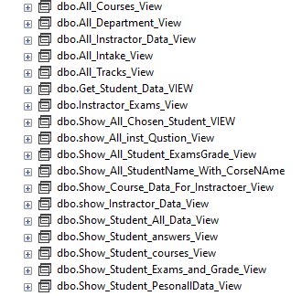

**Table_Function**

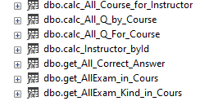

**Scaler_Function**

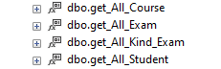

**Index**

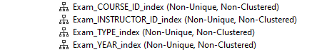

**Brief Description For All Objects in DB**

|  |  |
| --- | --- |
| **Stored Procedures** | **Description** |
| Add_New_Student_Proc | Proc To Add New Student |
| Update_Student_Proc | Proc To update Student |
| delete_Student_Proc | Proc To delate Student |
| select_Exam_to_Student_Proc | Proc To Chosen student |
| Update_Chosen_Student_Proc | Proc To update chosen Student |
| delete_Chosen_Student_Proc | Proc To delate chosen Student |
| Add_New_Exam_withRandomQuestion_Proc | Proc To Add New Exam random |
| Add_New_Exam_withManulQ_Proc | Proc To Add New Exam manul |
| Add_Question_to_Exam_Manully_Proc | Proc To Add question to exam manully |
| update_Exam_data_Proc | Proc To update exam data |
| update_Exam_Question_Proc | Proc To update or chenge exam Question |
| delete_Exam_Proc | Proc To Delete exam |
| InsertNewTraningManager | Proc To Insert new traning manager |
| DeleteTraningManager | Proc To Delete traning manager |
| UpdateTraningManager | Proc To Update traning manager |
| InsertNewBranch | Proc To Insert new branch |
| UpdateBranch | Proc To Update branch |
| DeleteBranch | Proc To Delete branch |
| InsertNewTrack | Proc To Insert new track |
| UpdateTrack | Proc To Update track |
| DeleteTrack | Proc To Delete track |
| InsertNewIntake | Proc To Insert new intake |
| UpdateIntake | Proc To Update intake |
| DeleteIntake | Proc To Delete intake |
| InsertNewDepartment | Proc To Insert new department |
| UpdateDepartment | Proc To UpdateDepartment |
| DeleteDepartment | Proc To DeleteDepartment |
| Show_Exam_Question | Proc To student Show_Exam_Question |
| Sudent_Choose_Exam | Proc To Sudent_Choose_Exam proc |
| Stuent_Set_Answer | Proc To Stuent_Set_Answer |
| Add_New_Instrctor_proc | Proc To Add Instructor |
| update_Instrctor_proc | Proc To Update Instructor |
| remove_Instrctor_proc | Proc To Delete Instructor |
| Add_New_Course_proc | Proc To Add Course |
| update_Course_proc | Proc To Update Course |
| delete_Course_proc | Proc To Delete Course |
| Add_New_Question_proc | Proc To Add Question |
| update_Question_proc | Proc To Update Question |
| delete_Question_proc | Proc To delete Question |
| get_Instructor_Data | Proc To Data Of Course And Instrctor |
| get_Student_Data | Proc To Data Of Course And Instrctor |
| get_ExData | Proc To Show Data Of Exam |
| get_Student_Data | Proc To Data Of Course And Instrctor |
| get_ExData | Proc To Show Data Of Exam |

**Function**

|  |  |
| --- | --- |
| **Scaler Function** | **Description** |
| get_All_Kind_Exam  get_All_Exam | Function To Return Total Exam |
| get_All_Course | Function To Return Total Course |
| get_All_Student | Function To Return Total Student |
| **Table Function** | **Description** |
| calc_Instructor_byId  calc_All_Course_for_Instructor | Function To Return Total Instructor |
| calc_All_Q_For_Course  calc_All_Q_by_Course | Function To Return Total Question for every Course |
| get_All_Correct_Answer | Function To Return Total Correct Answer |
| get_AllExam_Kind_in_Cours  get_AllExam_in_Cours | Function To return all exam in every course |

**Index**

|  |  |
| --- | --- |
| **Index** | **Description** |
| Exam_YEAR_index | Index For year index |
| Exam_COURSE_ID_index | Index For course index |
| Exam_INSTRUCTOR_ID_index | Index For instructor index |
| Exam_TYPE_index | Index For Type index |

**Trigger**

|  |  |
| --- | --- |
| **Trigger** | **Description** |
| Check_Exam_TotalDegree_trg | Trigger For Check Exam Total Degree Trigger |
| Calc_stu_Exam_finalReasult_trg | Trigger For Calc Exam final reasult of the students Trigger |
| pervent_Delete_Answer_trg | Trigger For pervent delete in student Answer  Trigger |
| pervent_Delete_Final_Reasult_trg | Trigger For pervent delete Exam final reasult of  student Trigger |

**Views**

|  |  |
| --- | --- |
| Show_Student_All_Data_View | View For Show student all data view |
| Show_Student_PesonallData_View | View For Show student personal data view |
| Show_Student_courses_View | View For Show student courses view |
| Show_Student_Exams_and_Grade_View | View For Show student exams view |
| Show_Student_answers_View | View For Show student answer exams view |
| Show_All_Student_ExamsGrade_View | View For Show all students exams final reasult view |
| Get_Student_Data_VIEW | View For Get_Student_Data_VIEW |
| Show_All_Chosen_Student_VIEW | View For Show_All_Chosen_Student_VIEW |
| show_Instractor_Data_View | View For show_Instractor_Data_View |
| Show_All_StudentName_With_CorseNAme | View For Show_All_StudentName_With_CorseNAme |
| Show_Course_Data_For_Instractoer_View | View For Show_Course_Data_For_Instractoer_View |
| show_All_inst_Qustion_View | View For show_All_inst_Qustion_View |
| Instractor_Exams_View | View For Instractor_Exams_View |
| All_Instractor_Data_View | View For All_Instractor_Data_View |
| All_Courses_View | View For All_Courses_View |
| All_Tracks_View | View For All_Tracks_View |
| All_Department_View | View For All_Department_View |
| All_Intake_View | View For All_Intake_View |

|  |  |
| --- | --- |
| **Per Permissions** | **Pass word** |
| Manager | 123 |
| Instructor | 123 |
| Student | 123 |

|  |  |
| --- | --- |
|  |  |
|  |  |
|  |  |
|  |  |
|  |  |